Supplementary material

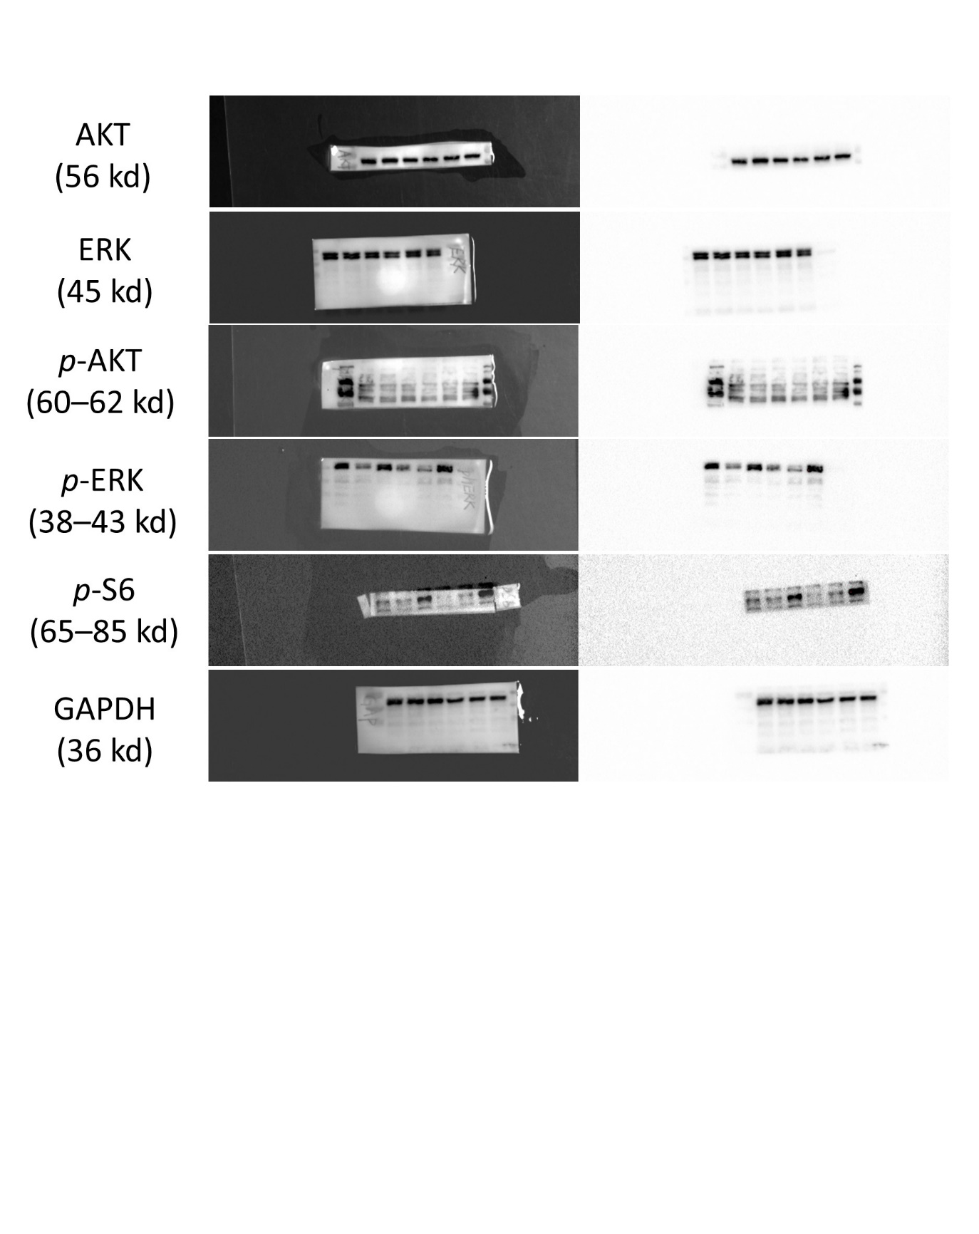

Supplementary Fig. 1. Uncropped western blot images. AKT: Ak strain transforming; ERK: extracellular signal-regulated kinase; GAPDH: glyceraldehyde-3-phosphate dehydrogenase.